**Fire detection System**

**Introduction**

In this project we are making fire detection system,**Fire Alarm System** is designed to alert us to an emergency so that we can take action to protect ourselves, staff and the general public.

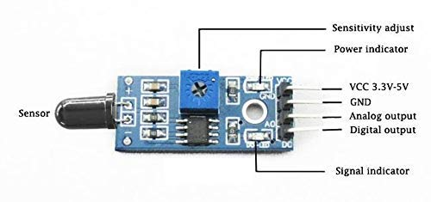

Components

Solderless Breadboard,  
Arduino nano  
Flame Sensor,  
16×2 LCD Display,  
100R Resistor x 3,  
4.7k Resistor,  
1k Resistor,  
LED Green ,  
LED Red ,  
Buzzer,  
Male to Male Jumper Wires,  
Battery clip,  
Battery 9v

Application

* Nuclear industry, pharmaceuticals, metal fabrication
* Agriculture, power flands and power plants
* Printing, spray booths, tunnels
* Aircraft hangars, clothing dryers and high voltage equipment
* Gas fuelled cookers and domestic heating systems
* Industrial heating and drying systems, and furnaces
* Industrial gas turbines and oil refineries
* Engine test facilities and engine rooms
* Generators and storage tanks.

Objective

During this activity ,you will help students to achieve following objectives

1. Understanding the principle and operation of flame sensor module
2. Design algorithm and flowchart to detect fire and get alerted
3. Programming Flame sensor module with arduino nano
4. Interfacing Flame sensor display module with arduino nano

Program

#include <LiquidCrystal.h>

LiquidCrystal lcd(2, 3, 4, 5, 6, 7);

int sensorPin = A0; // choose the input pin (for Fire sensor)

int buzzer = 13; // choose the pin for the Buzzer

int G_led = 8; // choose the pin for the Green LED

int R_led = 9; // choose the pin for the Red Led

int read_value; // variable for reading the sensorpin status

void setup(){

pinMode(sensorPin, INPUT); // declare sensor as input

pinMode(buzzer,OUTPUT); // declare Buzzer as output

pinMode(R_led,OUTPUT); // declare Red LED as output

pinMode(G_led,OUTPUT); // declare Green LED as output

lcd.begin(16, 2);

lcd.clear();

lcd.setCursor(0,0);

lcd.print(" WELCOME To ");

lcd.setCursor(0,1);

lcd.print(" Fire Detector ");

delay(2000);

lcd.clear();

}

void loop(){

read_value = digitalRead(sensorPin); // Digital input value

if(read_value==1){ // check if the Fire variable is High

lcd.setCursor(0, 0);

lcd.print(" Not Flame ");

lcd.setCursor(0, 1);

lcd.print(".....Normal.....");

digitalWrite(buzzer, LOW); // Turn LED off.

digitalWrite(R_led, LOW); // Turn LED off.

digitalWrite(G_led, HIGH); // Turn LED on.

}

else{ // check if the Fire variable is Low

lcd.setCursor(0, 0);

lcd.print("Fire is Detected");

lcd.setCursor(0, 1);

lcd.print("Alert....!!! ");

digitalWrite(buzzer, HIGH); // Turn LED on.

digitalWrite(R_led, HIGH); // Turn LED on.

digitalWrite(G_led, LOW); // Turn LED off.

delay(1000);

}

delay(100);

}

Hardware

1. Connect positive polarity of buzzer at D13 and negative polarity to ground
2. Connect anode of led1 to D9 and anode of LED 2 to D8 wheras both cathode terminal are grounded
3. Connect LCD data pin to D7,D6,D5,D4 of Arduino board and VCC and Vss pin to supply pin
4. Connect analog flame sensor VCC and GND to supply voltage pin and ground pin and signal pin to analog input pin A0

